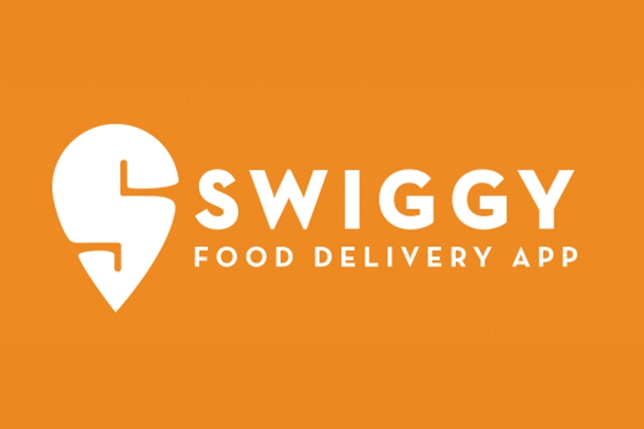

**Funnel Analysis Report**

Monika Chauhan

30/06/2024

**Business Case: Swiggy**

Swiggy is one of the largest food ecommerce platform in the country. Every day more than 1 million users are transacting on the platform.

all the insights related to the business case

Let’s generate insight on the company's performance in 2019. For this, I’m going to use the ‘Funnel Analysis’.

Identify date of highs and lows in the orders with respect to same day last week

As we already know that on **weekends**, Swiggy is getting extra orders naturally. Hence, we can see so many highs on weekends.

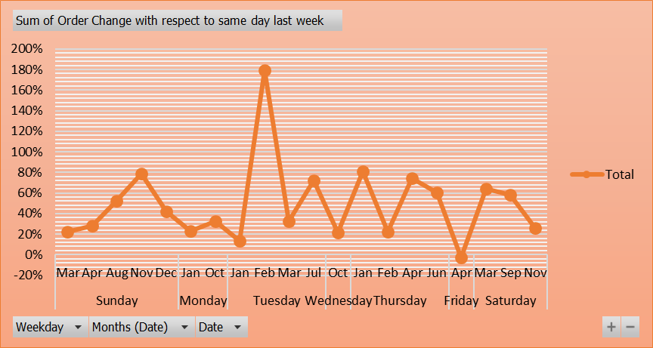

Also, the conditional formatting in the table below: clearly shows that the rows are more for green shades. That means we are having so many highs.

I have ignored any difference of less than 20% and above -20% in orders from the same day last week. Hence the highs or lows which are above 20% or lows below -20% are given below.

Mentioning the reason for the high/ drop in front of the date itself.

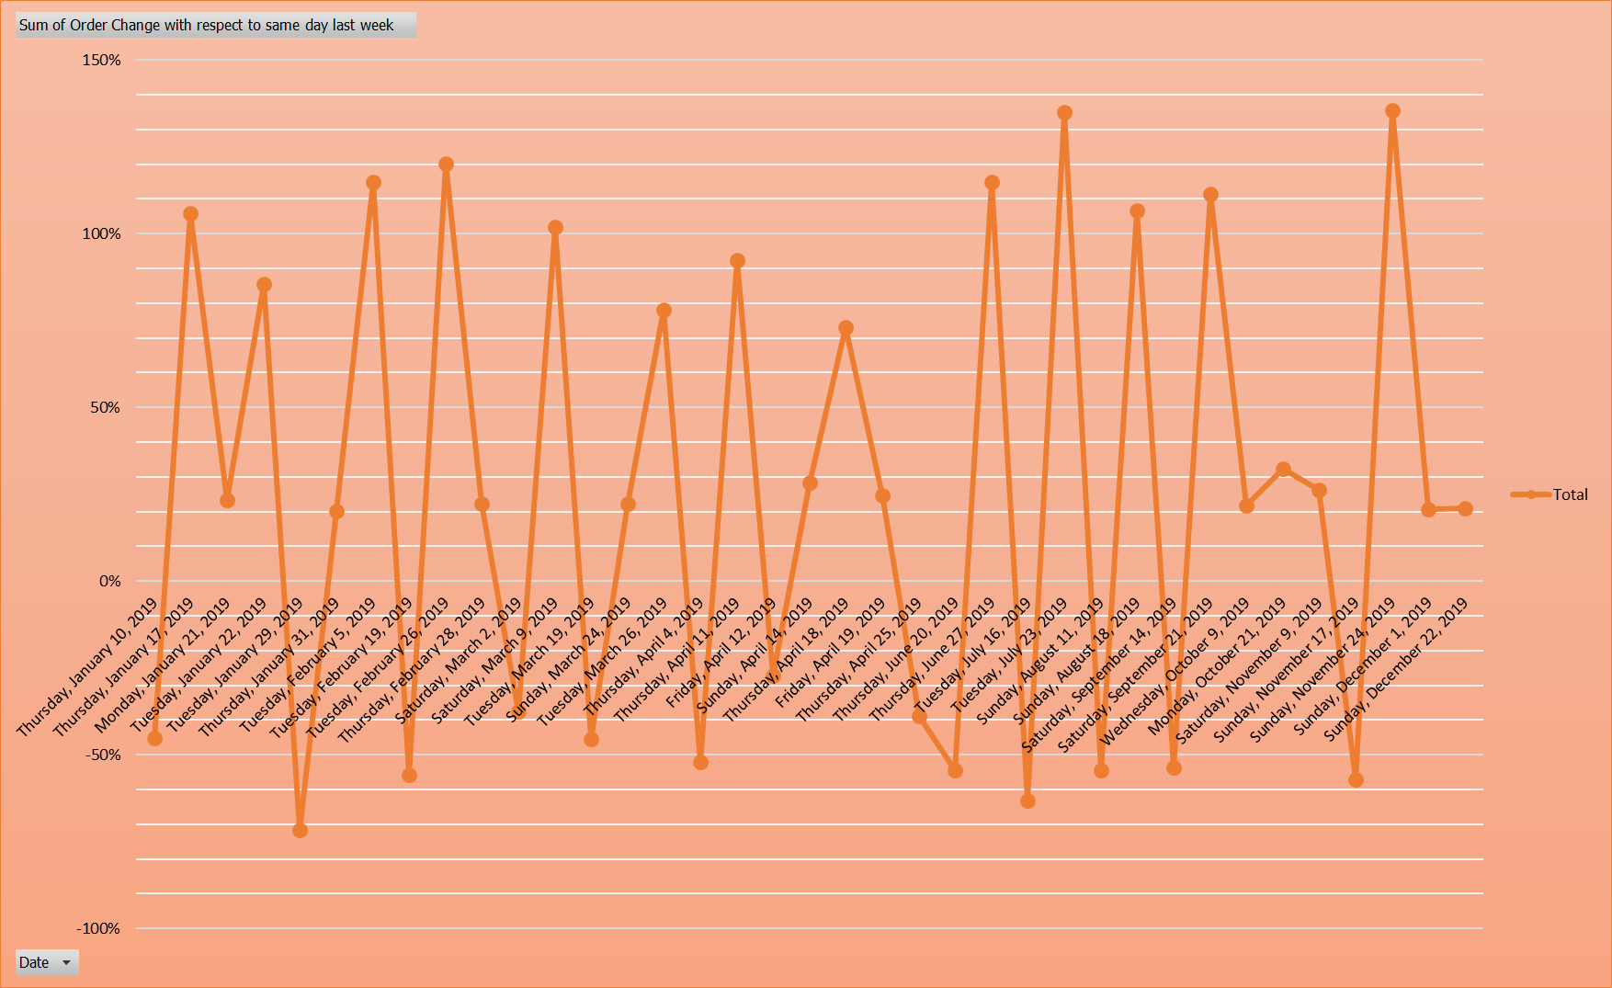

**List of dates having any order drop and hike as compared to last same day last week.**

|  |  |  |
| --- | --- | --- |
| **Date** | **Order Change with respect to same day last week** | **Reason** |
| 1/10/2019 | -45% | A significant promotion or discount offered by a competitor could divert customers away from Swiggy for that day. |
| 1/17/2019 | 106% | There might have been a special promotion or discount offered by Swiggy on that particular Thursday, encouraging more people to order. |
| 1/21/2019 | 23% | Order more food on Mondays as the transition from the weekend and may not have had time to grocery shop or prepare meals. |
| 1/22/2019 | 85% | Swiggy might have run a successful promotional campaign, leading to a spike in orders. |
| 1/29/2019 | -72% | The sharp decrease in orders was likely due to technical issues with the Swiggy app, combined with aggressive promotions by competitors on the same day. |
| 1/31/2019 | 20% | People might have been treating themselves as the weekend approached, contributing to the rise in orders. |
| 2/5/2019 | 115% | Introduction of popular new restaurants on the platform could have boosted orders. |
| 2/19/2019 | -56% | The sharp decrease in orders was likely due to technical issues with the Swiggy app. |
| 2/26/2019 | 120% | February has the most high orders, especially among younger demographics, due to reasons such as Valentine's Week celebrations, college events and parties. |
| 2/28/2019 | 22% | It’s the end-of-month spending habits, and social or corporate events boosting demand. |
| 3/2/2019 | -38% | A possible decline due to people starting the week with homemade meals. |
| 3/9/2019 | 102% | Monthly salary credits create predictable peaks in consumer spending, which businesses like food delivery platforms can capitalise on with targeted promotions or offers. |
| 3/19/2019 | -46% | Many people might be busy with festival preparations, leading to a decrease in orders as they prioritise other tasks. |
| 3/24/2019 | 22% | Favourable weather might have encouraged more people to order food delivery. |
| 3/26/2019 | 78% | March could be a month with higher consumer spending due to tax refunds or bonuses, increasing disposable income and food delivery orders. |
| 4/4/2019 | -52% | Economic downturn or fluctuations in disposable income could have reduced consumer spending on food delivery. |
| 4/11/2019 | 92% | People might be starting to wind down for the weekend and treat themselves with a food order. |
| 4/12/2019 | -27% | Saving money and appetite for the upcoming weekend. |
| 4/14/2019 | 28% | People may prefer staying in and ordering food as a relaxed end to their weekend. |
| 4/18/2019 | 73% | Mid-week fatigue setting in, leading to more people opting for food delivery. |
| 4/19/2019 | 25% | High likelihood due to leisure activities and gatherings |
| 4/25/2019 | -39% | Mid-week, people are trying to maintain a balanced schedule of cooking and ordering out. |
| 6/20/2019 | -54% | Minimal likelihood of decrease unless there’s a competing event or situation that causes people to dine out instead. |
| 6/27/2019 | 115% | Returning from vacations often leads to a preference for convenient options like food delivery, especially as individuals settle back into their routines. |
| 7/16/2019 | -63% | Preference for home-cooked meals likely contributed to the observed decrease in food delivery orders. |
| 7/23/2019 | 135% | Festivals, concerts, or sporting events can either increase or decrease orders based on where people choose to eat. |
| 8/11/2019 | -54% | Unlikely, but could be due to significant public events (e.g., festivals, sports events) that encourage people to eat out instead. |
| 8/18/2019 | 107% | High likelihood due to leisure activities, gatherings, and generally higher disposable income spending on weekends. |
| 9/14/2019 | -54% | Some people might cook at home as they prepare for the upcoming workweek. |
| 9/21/2019 | 112% | People may prefer staying in and ordering food as a relaxed end to their weekend. |
| 10/9/2019 | 22% | Promotions or discounts offered on hump day to boost mid-week sales. |
| 10/21/2019 | 32% | People may order more food on Mondays as they transition from the weekend and may not have had time to grocery shop or prepare meals. |
| 11/9/2019 | 26% | Cold or inclement weather might have encouraged more people to stay indoors and order food delivery. |
| 11/17/2019 | -57% | Many people might have been travelling for holidays or long weekends, reducing the local customer base. |
| 11/24/2019 | 135% | Increased social gatherings and celebrations during the holiday season often lead to higher demand for convenient food options. |
| 12/1/2019 | 21% | January often sees higher demand for food delivery as people return to regular routines after the holiday season. |
| 12/22/2019 | 21% | Weekend days like Sundays typically see higher orders as people have more leisure time and may prefer not to cook. |

Identify if traffic fluctuated as compared to the same day last week

After ignoring any difference of less than 20% and above -20% in orders from the same day last week. Hence the highs or lows which are above 20% or lows below -20% are given below.

The graph given below shows the change in traffic, the fluctuations in different sources of traffic as compared to the same day last week.

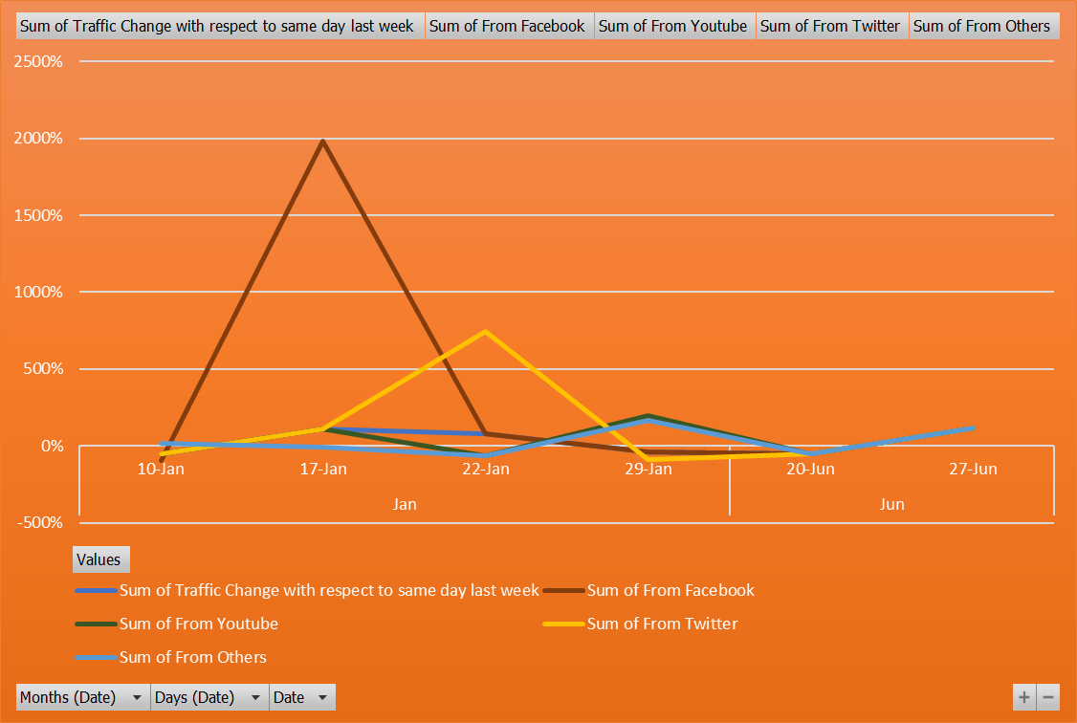

Mentioning the reason in reference to channel wise traffic for the high/ drop in front of the date itself.

**List of dates having any order drop and hike as compared to last same day last week.**

|  |  |  |
| --- | --- | --- |
| **Date** | **Traffic Change with respect to same day last week** | **Reason** |
| 1/10/2019 | -49% | Overall, traffic has decreased by 49% compared to the same day last week. Specifically, traffic from Facebook experienced a significant drop of 95%, indicating a steep decline in user engagement from this platform. Similarly, both YouTube and Twitter saw a 49% reduction in traffic, mirroring the overall trend. However, traffic from other sources bucked the trend with a 15% increase, suggesting that while major social media platforms saw decreased activity, alternative sources gained traction. |
| 1/17/2019 | 110% | A significant surge in traffic, with an overall increase of 110% compared to the same day the previous week. Traffic from Facebook saw an extraordinary spike, skyrocketing by 1980%, which suggests a major boost in user activity from this platform. YouTube and Twitter both experienced a 110% increase, aligning with the overall upward trend. However, traffic from other sources slightly decreased by 6%, indicating a minor drop in engagement from these channels despite the overall positive trend. |
| 1/22/2019 | 77% | A significant overall increase in traffic, which rose by 77% compared to the same day last week. This surge is largely driven by Facebook, which also experienced a 77% increase in traffic. Notably, traffic from other sources skyrocketed by an impressive 747%, indicating a substantial shift towards these platforms. Conversely, YouTube and Twitter saw significant declines, with traffic dropping by 65% and 60%, respectively. These contrasting trends highlight a dynamic shift in user engagement across different platforms. |
| 1/29/2019 | -40% | Traffic has experienced a 40% decline compared to the same day last week. Notably, Facebook traffic mirrored this overall trend with a 40% drop. In contrast, YouTube saw a substantial increase in activity, with traffic surging by 198%. Similarly, traffic from other sources rose significantly by 166%. However, Twitter experienced a sharp decline, with traffic plummeting by 88%. These variations indicate a dynamic shift in user engagement across different platforms. |
| 6/20/2019 | -53% | There has been a uniform decline in traffic across all platforms, with an overall decrease of 53% compared to the same day last week. This trend is consistent across major social media platforms, including Facebook, YouTube, and Twitter, each experiencing a 53% reduction in traffic. Other sources also mirrored this decline, showing a 53% drop. This widespread reduction suggests a significant overall decrease in user engagement and activity across all measured platforms. |
| 6/27/2019 | 119% | Traffic has seen a significant surge, increasing by 119% compared to the same day last week. This remarkable growth is consistent across all major sources, with traffic from Facebook, YouTube, Twitter, and other sources each experiencing a 119% increase. This uniform rise in traffic across multiple platforms indicates a broad-based boost in user engagement and activity, reflecting a highly positive trend in overall online presence. |

Identify if Overall conversion as compared to the same day last week

Smaller conversions leading to the impact (L2M, M2C, C2P, P2O) i.e. increase or decrease in the orders.

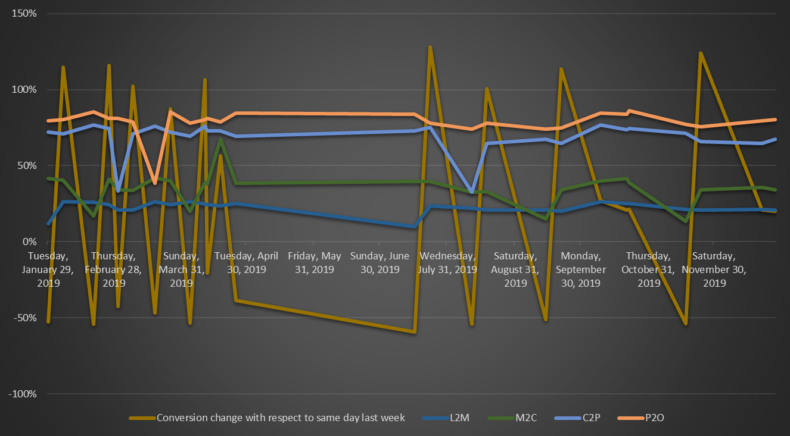

1/29/2019

Overall Conversion is -52% decline in the count of restaurants compared to the same day last week.

2/5/2019

Overall Conversion is 115% as the count of restaurants and also a slight increase in the average discount.

2/19/2019

Overall Conversion is -54%, since there is a uniform decline in almost parameters such as count of restaurants, cost for two, Out of stock Items per restaurant, Number of images per restaurant and success rate of payment.

2/26/2019

Overall Conversion is 116% as a significant surge, increasing by 116% compared to the same day last week. This remarkable growth is consistent across all major sources, especially number of images per restaurant and success rate of payment.

3/2/2019

Overall Conversion is -42% indicating a steep decline in count of restaurants,average packaging charges, but other parameters increased a lot i.e. out of stock items per restaurants, average delivery charges, cost for two, Out of stock Items per restaurant, Number of images per restaurant and success rate of payment.

Other dates also have the similar reasons for the overall drop/ high in conversions.

**List of dates having any overall conversion drop and hike as compared to last same day last week.**

